試寫出下列兩篇文章的大意及心得：
文章(一)
1. The Stiffness Matrix and Equivalent Spatial Loads of the Curved Box Girder Element
Since the curved prestressed girder bridge is a spatial force reception structure, and as all studies, both local and international, conducted on the curved prestressed girder bridges mainly focused on its vertical load conditions; therefore, this paper shall first derive the equivalent nodal forces of the curved girder element under the application of arbitrary spaced forces. This shall serve as the foundation of the statical analysis of this bridge type.
1.1 The Element Stiffness Matrix and Flexibility Matrix of the Spatial Curved Box Girder
When using the curved coordinate (Figure 1), the 7 displacements encountered by the end j of the curved girder element i,j are: 3 translational displacement, 3 rotational displacement and 1 warping torsion displacement. The flexibility matrix of end j $\left[F_{\text{jj}}\right]$of the curved girder element may be obtained through the strain energy and Castigliano’s theorem.
The stiffness matrix of the curved box girder element is[1,2] :
$\left[K\right]=\left[\begin{matrix}K_{\text{ii}} & K_{\text{ij}} \\ K_{\text{ji}} & K_{\text{jj}}\end{matrix}\right]$ (1)
in which
$$\left[K_{\text{jj}}\right]={\left[F_{\text{jj}}\right]}^{−1} ; \left[K_{\text{ij}}\right]=−\left[T\right]\left[K_{\text{jj}}\right] ; \left[K_{\text{ji}}\right]={\left[K_{\text{ij}}\right]}^{T} ; \left[K_{\text{ii}}\right]=−\left[T\right]\left[K_{\text{ji}}\right]$$
$\left[T\right]$ stands for force transformation matrix

1.2 The Equivalent Nodal Load of the Curved Girder Element under Arbitrary Spatial Forces
This paper shall turn the 8 spaced forces (e.g.: radial concentrated force, vertical concentrated force, tangential concentrated force, concentrated torsion, radial distributed force, vertical distributed force, tangential distribution force and distributed torsion, etc.) into the equivalent nodal loads for the purposes of providing a foundation for the analysis of the curved prestressed concrete girder.
We shall now take the restraint release of end j for a curved girder element i j and convert it into the primary structure (Figure 1), we may then establish an equation through the theory of force method:
$\left[F_{\text{jj}}\right] {\left\{X\right\}}_{j}+\left\{Δ_{P}\right\}=\left\{0\right\}$ (2)
In the equation,
$\left[F_{\text{jj}}\right]$ stands for structural flexibility matrix; ${\left\{X\right\}}_{j}$ stands for structural basic unknowns, which are the restrained forces; $\left\{ Δ_{p}\right\}$ stands for the displacements of the primary structure in the direction of the basic unknowns.
The$\left\{ Δ_{p}\right\}$ can be obtained from the Castigliano’s theorem; and after the $\left\{ Δ_{p}\right\}$ has been obtained, it should be included into equation (2) to obtain the 7 fixed end reactions of the curved girder element end j.
When the primary structure is subjected to the equilibrium conditions and warping torsion differential equation; then we may be able to obtain the expression of internal forces under the 8 types of spaced forces [2]: If we are to put the 7 fixed end reactions of the curved girder element end j through the force transformation matrix; then we will be able to obtain the end i reactions. If it is superposed with the expression of internal forces of the 8 types of spaced force applications; then we shall be able to obtain the 7 fixed end reaction of the curved girder element end i. After obtaining the fixed end reactions of the curved girder element, we shall now take the fixed end reaction variables of the two element ends for the equivalent nodal loads of the curved girder element.
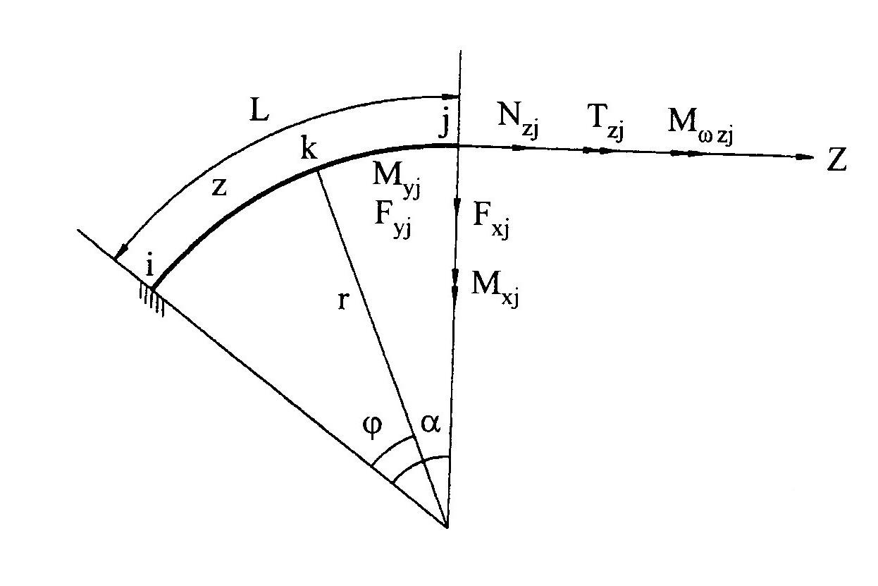
Figure 1 Curved Coordinate System

文章(二)
NASA's newest building at the Ames Research Center at Moffett Field, has won the distinction of being certified as the nation's "greenest" federal building. Known as "Sustainability Base," the 50,000-square-foot, two-story office building is visually stunning: Sunlight streams through skylights, windows actually open, and the office floor plan has scrapped private offices in favor of open spaces that encourage teamwork and collaboration.
The $25 million building integrates a host of clean-energy components, including fuel cells from Bloom Energy, solar panels, a water recovery system and building controls that can react to subtle changes in sunlight, temperature, wind and occupancy. The U.S. Green Building Council's Leadership in Energy and Environmental Design (LEED) unit has awarded the building LEED Platinum status, the highest rating possible.
"This building generates more electricity than it consumes, which allows us to support the energy needs of other buildings on the campus," Steve Zornetzer, associate director of NASA Ames Research Center, said during a sneak peak of Sustainability Base on Thursday. "It's not just net energy zero, it's net-positive. And it uses 90 percent less water than other buildings."
The building's official dedication will be Friday; U.S. Reps Anna Eshoo, D-Palo Alto, and Zoe Lofgren, D-San Jose, are among those expected to attend.
NASA, in collaboration with lead architect and engineering firm AECOM and designer William McDonough and Partners of Charlottesville, Va., and San Francisco, designed the building to be "native to place," which means it incorporates the natural landscape into the design. The interior is made from nontoxic and recycled materials, and the white oak flooring comes from salvaged wood. So-called "gray water" from sinks and showers is reused in toilets. The building does not have air conditioning, but can cool interior temperatures by circulating cold water through copper pipes in the ceiling.
A growing body of research shows that green buildings, which capitalize on fresh air and natural light, reduce stress and improve productivity among workers. "People love being able to see the outdoors while they are working," said McDonough, who planted 100 additional trees on the campus.
NASA views Sustainability Base as a prototype of what a 21st-century building should be, and the way the agency should think about building in the future. About 200 NASA employees work in the new building, which includes the Stratospheric Observatory for Infrared Astronomy, or SOFIA, program. Outdoor patios are designed to serve as work spaces and meeting areas, complete with wireless Internet access. Eventually, umbrellas on the patios will be covered with thin solar films and have charging stations for smartphones and iPads.

