- Write down the domain and range of each function. 3%
1.1 $y=2\sqrt{x}$ 1.2 $y=\frac{\left\lfloor x\right\rfloor }{2}$ 1.3 $y=\frac{1}{(x−1)^{2}}$
- Write the answers of each question. 3%
2.1 $\underset{v→∞}{\text{lim}}(\frac{1−v^{2}}{1+2v^{2}})(\frac{8v^{2}+7v}{4v^{2}})$ 2.2 $\underset{x→∞}{\text{lim}}\frac{\text{ln}x}{x}$ 2.3 $\underset{n→∞}{\text{lim}}(1+\frac{x}{n})^{n}$
- According to the equation$y=4x^{3}−x^{4}$, (1) write down the interval where y is increasing and is decreasing; (2) write down the interval where y is concave up and is concave down; (3) write down all of its local extreme points and inflection points. 14%
- Find the derivatives of y. (Find dy/dx.)24%
4.1 $y=\frac{1}{3x^{2}}−\frac{5}{2x}$ 4.2 $y=\text{ln}(3{\text{xe}}^{−x})$ 4.3 $y=\frac{e^{−x}}{e^{x}+1}$
4.4 $y=(1+{\text{tan}}^{4}(\frac{x}{\text{12}}))^{3}$ 4.5 $x^{2}y+{\text{xy}}^{2}=6$ 4.6 $y={\text{log}}_{2}x×{\text{log}}_{4}x$
4.7 $y=x^{\text{sin}x}$ 4.8 $y={\text{tan}}^{−1}\sqrt{x^{2}−1}+{\text{csc}}^{−1}x,\text{ x}>1$
- Evaluate the integrals. 40%
5.1 $\int{\frac{t\sqrt{t}+\sqrt{t}}{t^{2}}}\text{dt}$ 5.2 $\int{{\text{sin}}^{2}x\text{dx}}$ 5.3 $\int{3y\sqrt{7−3y^{2}}\text{dy}}$
5.4 $\int{2{\text{xe}}^{x^{2}}\text{cos}(e^{x^{2}})\text{dx}}$ 5.5 $\int{7^{\text{cos}t}\text{sin}t\text{dt}}$ 5.6 $\int{\frac{4}{x(\text{ln}x)^{2}}\text{dx}}$
5.7 $\int{\frac{2\text{cos}θdθ}{1+(\text{sin}θ)^{2}}}$ 5.8 $\int{x\text{ln}x\text{dx}}$ 5.9 $\int{(x^{2}−5x)e^{x}\text{dx}}$
5.10 $\int{\frac{x+4}{x^{2}+5x−6}\text{dx}}$
- Find the areas of the shaded regions graphed below. 6%
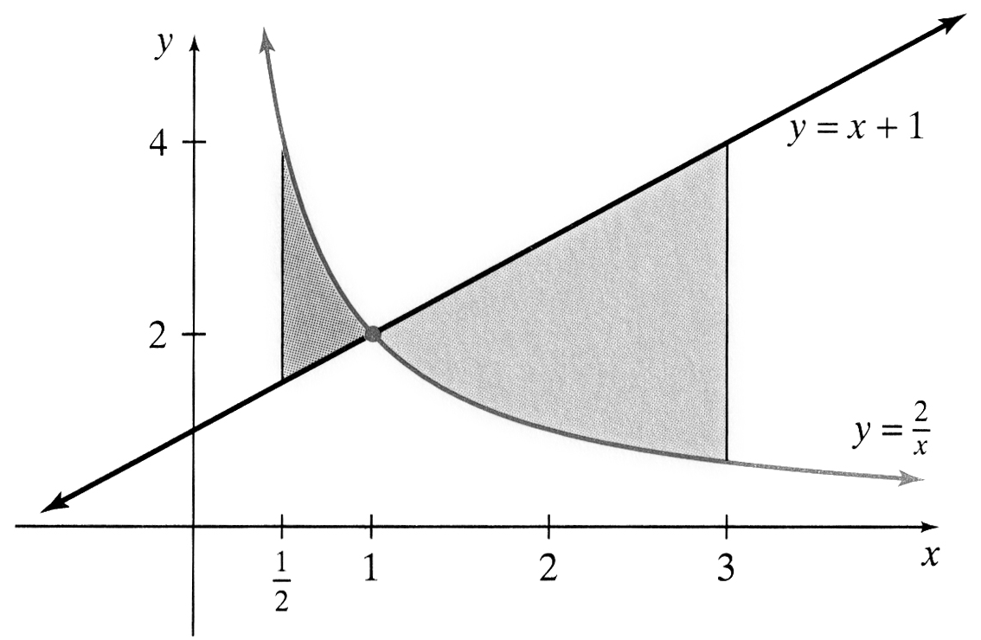
- The region bounded by the curve $y=x^{2}+1$ and the line $y=−x+3$ is revolved about the x-axis to generate a solid. Find the volume of the solid. 10%

